Task B: Threat Modelling and SDLC
Word Count – 1000 words

Table of Contents
1. Introduction 3
2. Attack Surface Analysis 4
3. STRIDE Threat Modeling 5
4. Threat Identification 6
Table: Threat Identification 6
5. Threat Evaluation 6
Table: Threat Evaluation 6
6. Security Requirements 7
7. SDLC Integration 7
Table: SDLC Integration 7
8. Summary 8

List of Figures
Figure 1: Data Flow Diagram (DFD) 4

List of Tables
Table 1: Threat Identification 6
Table 2: Threat Evaluation 6
Table 3: SDLC Integration 7

Introduction
Threat modeling is a systematic process that enables the identification and management of security threats that arise at the early stages of designing any system. In this document, a threat model will be constructed for a purposely weak web application that uses Flask, SQLite, and HTML. The application supports user registration, login, product listing, role escalation to seller, product management, and a review system, alongside an administrative interface. Unlike abstract systems, this application exposes real, code-level vulnerabilities such as unsanitised SQL queries, insecure cookie-based authentication, and a lack of output encoding. Architecture involves the client browser accessing the Flask web service, which interacts directly with the SQLite database. The important trust boundaries lie between the client and the server and between the application and the database, where the danger lies when cookies managed by the client are trusted for authentication purposes. The Data Flow Diagram (DFD) shows the interaction among different processes, such as authentication, managing products, and reviewing. The STRIDE methodology is applied to systematically identify threats across these flows. This way, it becomes possible for us to not only classify threats, but also link them directly with implementation flaws. This will enable us to come up with effective countermeasures and include them in the Software Development Lifecycle (SDLC) process.
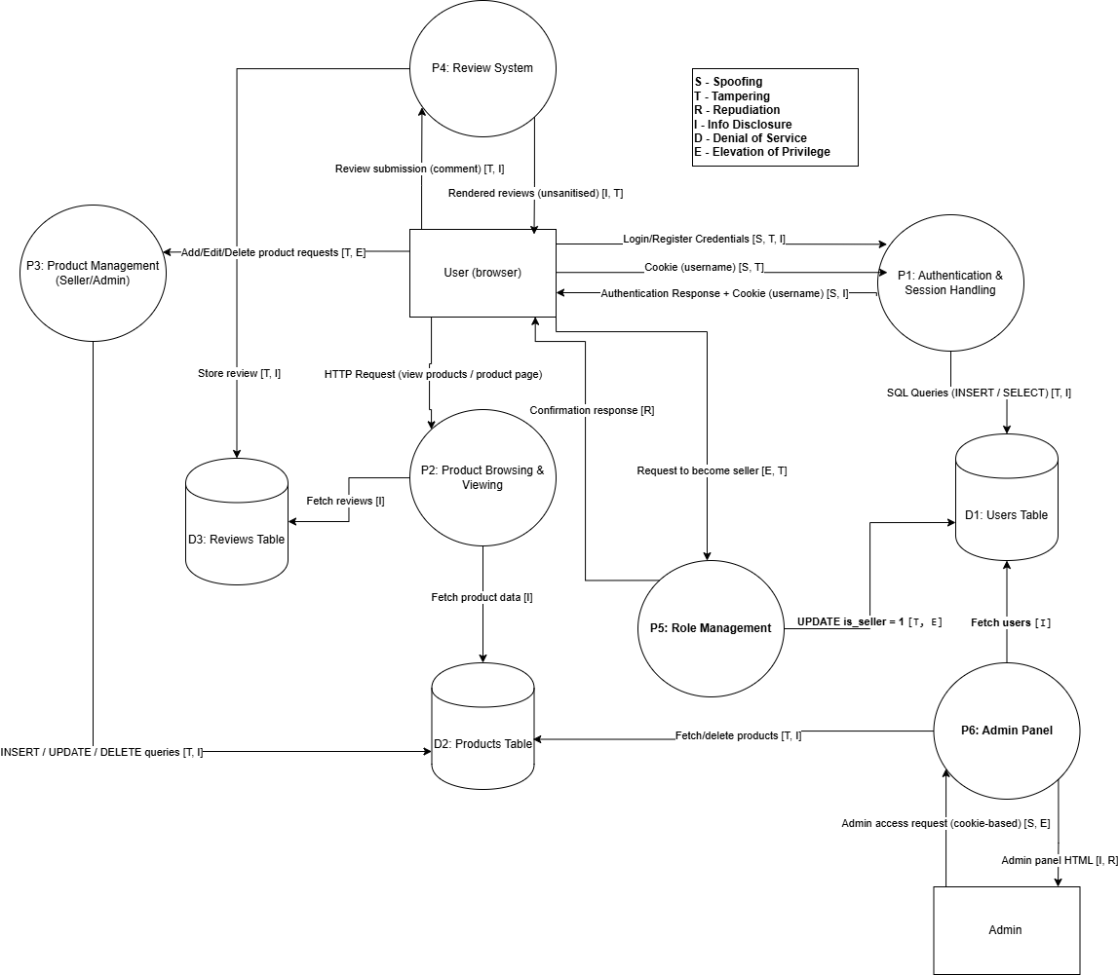
Figure 1: Data Flow Diagram (DFD)

Attack Surface Analysis
The application contains multiple entry points because it depends on unverified user data and uses unsafe design methods. The most critical entry points are HTTP endpoints such as /login, /register, /add, /edit, /delete, /product/, and /admin. The endpoints handle untrusted input, which they use to construct SQL queries and HTML responses. Authentication represents a major weakness. Unlike secure session management, which relies on server-side sessions, the application instead uses cookies on the client side with the username. The cookie is not signed or verified and can therefore be manipulated by an attacker, enabling him/her to act as an administrator. The database interface layer raises significant risks. Every SQL statement is created via string interpolation; thus, the application becomes highly susceptible to SQL injection attacks from various sources, such as user login, user registration, product creation, and review submission. This brings to light all the data underneath, even passwords kept in plain text. Another point where an attack can take place is via the storage of cross-site scripting (XSS), brought about by the review mechanism. Comments left by users on posts are saved and processed without being filtered first. Any authorized user can easily become a seller without any form of verification, while no rigorous checks for endpoint product modifications exist. These vulnerabilities, when combined with cookie manipulation methods, can lead to full privilege escalation. The absence of any form of rate-limiting, validation checks, and security headers further compromises the system's safety from exploitation attacks.

STRIDE Threat Modeling
The STRIDE framework is applied to systematically categorise threats across system components and data flows. Each of these categories presents serious vulnerabilities that are a direct result of the poor implementation of the system. The spoofing threat is high because the system utilizes an unsigned username cookie to authenticate the user’s identity. An attacker is able to assume the identity of anyone, including an administrator, by forging this cookie. Database content, such as product details and user privileges, can change due to injections. The issue of repudiation arises since there are no logs and auditing mechanisms. Actions such as deleting a product or gaining additional privileges cannot be traced back to specific users. Information leakage issues arise from SQL injection, plain-text passwords, and the exposure of users' private information within the admin panel. The sensitive information can be acquired conveniently. The vulnerability to a DOS attack is possible because of the lack of appropriate means of handling requests and queries, which will allow the attacker to send too many requests at once to the program. The elevation of privilege attack can be easily executed because of the improper role management and reliance on cookie-based authentication.

Threat Identification
Table 1: Threat Identification
Component | STRIDE Threat | Description | Example Scenario | Mitigation
P1: Authentication | Spoofing | User identity is based on unsigned cookie | Attacker sets cookie username=admin to gain admin access | Use server-side sessions, signed cookies
P1: Authentication | Tampering | SQL queries constructed using user input | Inject ' OR '1'='1 in login form to bypass authentication | Parameterised queries / ORM
P1: Authentication | Information Disclosure | Passwords stored in plaintext | Database leak exposes all user credentials | Hash passwords using bcrypt/Argon2
P1: Authentication | Repudiation | No logging of login attempts | User denies performing login activity | Implement secure audit logging
P2: Product Browsing | Information Disclosure | All product data exposed without filtering | Unauthorized users view all product details | Enforce access control if needed
P2: Product Browsing | Tampering | Dynamic HTML rendering without encoding | Inject script via stored data displayed on homepage | Output encoding (escape HTML)
P3: Product Management | Tampering | No validation on product inputs | Attacker modifies product price or description | Input validation + sanitisation
P3: Product Management | Elevation of Privilege | Weak role checks for product control | User becomes seller and edits all products | Enforce ownership checks + RBAC
P3: Product Management | Repudiation | No logging of product changes | Seller denies modifying or deleting product | Maintain audit logs
P4: Review System | Tampering | User input stored without sanitisation | Submit malicious JavaScript in review | Input sanitisation
P4: Review System | Information Disclosure | Stored XSS steals session data | Script extracts cookies of other users | CSP + HttpOnly cookies
P5: Role Management | Elevation of Privilege | No verification for seller role | Any user upgrades to seller role instantly | Require admin approval / verification
P6: Admin Panel | Elevation of Privilege | Admin access based on cookie value | Attacker spoofs admin cookie | Strong authentication + role validation
P6: Admin Panel | Information Disclosure | Admin panel exposes user list | Attacker gains access to all usernames | Restrict access + logging
Server/API | Denial of Service | No rate limiting or request controls | Flooding endpoints with requests | Rate limiting + monitoring

Threat Evaluation
Table 2: Threat Evaluation
Threat | Likelihood | Impact | Risk Level | Justification
Cookie Spoofing | High | Critical | Critical | Authentication relies entirely on an unsigned client-side cookie. An attacker can trivially modify the cookie value to impersonate any user, including admin, leading to complete compromise of confidentiality, integrity, and system control.
SQL Injection | High | Critical | Critical | SQL queries are constructed using unsanitised user input across multiple endpoints (login, registration, product management). Exploitation requires minimal skill and allows attackers to bypass authentication, extract database contents, or modify data.
Stored XSS | High | High | High | User-generated reviews are stored and rendered without output encoding. Attackers can inject persistent scripts that execute in other users’ browsers, leading to session hijacking and data theft.
Privilege Escalation | High | Critical | Critical | Role management is weak, allowing any authenticated user to become a seller without verification. Combined with cookie spoofing, attackers can escalate privileges to admin level and gain full system access.
Data Disclosure | Medium | High | High | Sensitive data such as usernames and plaintext passwords are stored insecurely and can be exposed through SQL injection or unauthorised admin panel access, compromising user privacy and system trust.
Denial of Service | Medium | Medium | Medium | The application lacks rate limiting and resource controls, making it vulnerable to request flooding. While not directly compromising data, it can degrade availability and disrupt legitimate user access.
Repudiation | Medium | Medium | Medium | The system lacks logging and audit trails for critical actions such as login, product modification, and role changes. This prevents accountability and makes it difficult to investigate malicious activities.

Security Requirements
Security controls must directly address the identified implementation flaws. Redesigning authentication based on session management that uses secure techniques will address this problem. Sessions should be server-side, signed, and protected with attributes such as HttpOnly, Secure, and SameSite. Passwords must be hashed using strong algorithms such as bcrypt, eliminating plaintext storage. All database interactions must use parameterised queries or ORM frameworks to prevent SQL injection. Input validation must be done to ensure that all user input conforms to constraints like type, length, and format. Output encoding is critical to prevent XSS, particularly in dynamically rendered HTML. Access control must be strictly enforced using role-based access control (RBAC). In case of sensitive actions like modifying products and accessing administrative features, the system must confirm both authentication and authorization. Role escalation should require administrative approval or verification mechanisms. Data protection should include encryption of sensitive data at rest and in transit using TLS. Content Security Policy (CSP) headers can be included in the application. Operational security measures such as rate limiting, logging, and monitoring must be introduced to detect and respond to suspicious behaviour. Logs must be tamper-proof and provide enough information for forensic investigation.

SDLC Integration
Table 3: SDLC Integration
SDLC Phase | Security Integration
Requirements | Define security requirements based on identified threats, including secure session-based authentication (replacing cookie-based identity), strong password hashing (bcrypt), role-based access control (RBAC), and strict input validation. Establish security acceptance criteria such as “no direct SQL queries with user input” and “all outputs must be encoded.”
Design | Perform STRIDE-based threat modelling using the developed DFD to identify trust boundaries, particularly between client cookies and server logic. Design secure authentication flows using server-side sessions, enforce least privilege for seller/admin roles, and incorporate defence-in-depth principles for database access and input handling.
Implementation | Eliminate insecure coding practices observed in the application, such as f-string SQL queries and dynamic HTML rendering. Implement parameterised queries, input validation, and output encoding. Replace plaintext password storage with secure hashing and ensure proper session management instead of trusting client-side cookies.
Testing | Conduct security-focused testing targeting actual vulnerabilities in the system, including SQL injection, stored XSS, and authentication bypass. Use static analysis tools to detect insecure queries and dynamic testing tools (e.g., OWASP ZAP, Burp Suite) to simulate real-world attacks. Include test cases for privilege escalation and role enforcement.
Deployment | Harden the deployment environment by enforcing HTTPS (TLS), secure cookie attributes (HttpOnly, Secure, SameSite), and proper server configurations. Disable debug mode in production and ensure secrets such as the Flask secret key are securely managed. Apply least privilege to database access.
Maintenance | Continuously monitor application logs for suspicious activity such as repeated login attempts or unusual role changes. Regularly update dependencies and patch vulnerabilities. Periodically review and update the threat model to reflect new attack vectors, and perform ongoing security audits and penetration testing.

Summary
This report demonstrates a comprehensive threat model for a vulnerable web application by directly analysing its implementation. Unlike generic models, the assessment identifies real, exploitable weaknesses such as SQL injection, cookie spoofing, and stored XSS. STRIDE analysis made possible the structured categorization of these threats, whereas the process of risk assessment helped in identifying important weaknesses that needed prompt attention. Security requirements suggested by us are specific to the architecture of the system being built and have been developed keeping in mind addressing the underlying cause of the threat. The approach clearly shows defensive thinking in its implementation and is consistent with industry standards. Generally speaking, the assessment demonstrates that insecure design contributes to the increase of the attack surface in a significant way, stressing once again the need for secure programming, authentication, and threat modeling.

